METROPOLITAN POLICE DEPARTMENT
FIFTH DISTRICT
CITIZENS’ ADVISORY COUNCIL

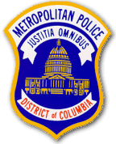

ANNUAL AWARDS DINNER

THE HECHT WAREHOUSE @ IVY CITY
1401 New York Avenue, N.E.
Washington, DC 20002
(Enter on Okie Street, N.E. – Free Garage Parking)

Friday, October 28, 2016
7:00 p.m. until 10:00 p.m.
(Reception commencing at 6:00 p.m.)

Tickets: $40.00 per person

For more information regarding the awards dinner and/or to purchase tickets for the event, please contact CAC Chairperson Frances Penn at 202-230-2727/email: fspenn@yahoo.com.

